

Guide on Financial Authorizations for UN Volunteer assignments
New assignment, extension, change of Costing during the assignment
Last update: 11 December 2024

Contents

I. What is a Financial Authorization? 2
II. Types of Financial Authorizations 2
III. Mandatory content of a Financial Authorization 3
IV. What is Service Clearing Account? 3
V. Service Clearing Account Workflow 4
VI. Entering Funding Confirmation and uploading Financial Authorization in UVP 4
VII. Frequently asked questions on Financial Authorizations 4
VIII. Annexes 7
Annex 1: Examples of the Costing structure for Quantum UN Entities 7
Annex 2: Sample copy of UMOJA FA 8
Annex 3: Sample of a non-UMOJA FA in a standard template shared by UNV 9

What is a Financial Authorization?

A Financial Authorization (FA) is an official document received from UN Entities to confirm their commitment to fund a UN Volunteer Assignment and the availability of funding, and to authorize UNV (United Nations Volunteers) to charge the related costs.

The FA must cover the total proforma cost for the full contract period, including contracts that spread over multiple years.

The UNDP Financial Rules do not allow pre-financing. Without a FA confirming funding availability for the full contract duration, UNV cannot initiate or extend a volunteer contract.

If a UN Entity cannot provide a FA over multiple years but requests volunteer services for that period, the contract can only be established up to the end of the period specified in the FA. Extension of the contract can only be processed once the FA for the subsequent period is provided.

No volunteer can be offered, contracted or extended without valid Financial Authorization.

In exceptional, justified cases authorized by the Regional Manager, based on documented evidence of Host Entity commitment to fund the assignment (refer to Memo and complete administrative instructions for exceptions to the conditions of service), interviews and selection of the candidate can take place prior to the provision of the Financial Authorization.

Please note UNV does not send any offer to a selected candidate until a valid FA, containing all relevant information, has been provided by the UN Entity.

Types of Financial Authorizations

There are two types of FAs:

  - Issued by Quantum UN Entities (UNDP, UNCDF, UNU, UNV, UN Women, UNITAR, UNFPA, UNSSC, WMO, ICAO). Although filled out and signed by the above entities, the template for these FAs is provided by UNV and is titled UNV Service Request Form (SRF). These FAs/SRFs are sub-divided in:

- PPM SRFs (applicable for UN Women, UNU, UNV, UNDP, UNCDF). Please use the PPM SRF template when requesting FAs from PPM Quantum entities.

- non-PPM SRFs (applicable for UNFPA, UNITAR, UNSSC, WMO, ICAO). Please use the non-PPM SRF template when requesting FAs from non-PPM Quantum entities.
*Costing structures of PPM and non-PPM Quantum entities are provided for reference in Annex 1.

  - Issued by non-Quantum UN Entities. These Entities are not using Quantum as their ERP, and are requesting service provision from UNDP/UNV by using the UNDP Service Clearing Account (SCA) mechanism, detailed in parts IV and V of this guide. These FAs are sub-divided in:

- UMOJA FAs (applicable for OHCHR, UNODC, UNEP, all Missions, UN Secretariat). These FAs are generated by the UMOJA ERP and have a standardized form. A sample of a UMOJA FA is provided for reference in Annex 2.

- non-UMOJA FAs/SRFs (applicable to the rest of non-Quantum entities). UN Entities not using UMOJA can either provide an FA generated by their own system as long as it fulfils the FA mandatory content, or use the UNV AGENCY SERVICE REQUEST FORM. A sample of a non-UMOJA FA is provided for reference in Annex 3.

Mandatory content of a Financial Authorization

The FA must include at least the following information:
- Issuing UN Entity (Name and Donor Code)
- Service requested, including details on type, category and number of UN Volunteers required, duration of contract, initial contract or extension, duty station and country of the assignment.
- Total authorized amount and currency. This should match the proforma cost of the full contract period.
- Costing information (full Quantum distribution, or Agency Reference for non-Quantum Entities). The Agency Reference information refers to UN Entity internal budget lines and is usually coded under three components: Unliquidated Obligation (ULO), Agency Reference, and Agency Project codes. These codes will assist the UN Entity in identifying the specific FA in their system and liquidate the related financial obligations once monthly reports on SCA transactions received from UNDP.
- Name and signature of Authorizing Officer, including FA issuance/signature date (for authorized signatories of each SCA UN Entity, please refer to the UNDP Portal for UN Agency Partners, in case of inaccuracy please flag them to GSSC). UNV accept FAs that adhere to the respective Host Entity’s policy on electronic signatures.

What is a Service Clearing Account?

- Service Clearing Account (SCA) is a mechanism established by UNDP to accommodate a financially sustainable service provision to non-Quantum UN Entities.
- Through SCA, the UN Entity pre-funds the UNDP SCA account, and then requests service provision from the prefunded account by detailing the needed service in the officially signed FA (UNDP applies the funds received to the SCA fund code 12000 against the UN Entity donor code, and then records all costs related to the provided services to that Entity on the same fund/donor combination).
- Without a signed FA, UNDP/UNV is not allowed to charge anything against the SCA account of a UN Entity.
- UNDP GSSC monthly compiles the SCA debit/credit transactions and shares them with SCA Entities for review and acceptance. The reports are also available on the UNDP Portal for UN Agency Partners.
- The monthly SCA reports include the charges from both UNDP Offices and UNV.
- For additional details, please access the SCA SOP.

Service Clearing Account Workflow

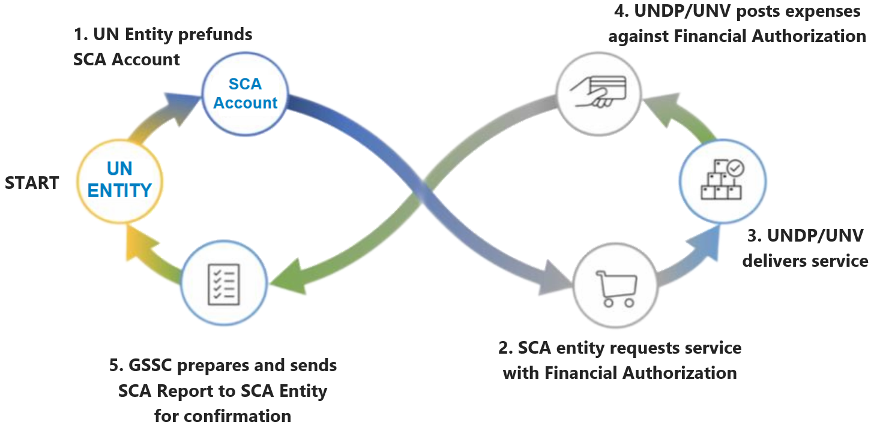

Entering Funding Confirmation and uploading Financial Authorization in UVP

To familiarize yourself with the funding confirmation and financial authorization for UN Entities, please consult the “Create a new Description of Assignment in UVP” section of the Draft and Publish an Onsite Description of Assignment SOP.

Additionally, please refer to this guide on steps to follow when entering funding confirmation and uploading a financial authorization in UVP.

Frequently asked questions on Financial Authorizations

Things which could go wrong | Reason/impact | How to mitigate?
FA without complete information and authorized signature or document other than FA | - Deployment blocked/delayed  - Charge to wrong UN Entity; and/or rejection by UN Entities  - Financial liability to UNV  - Requires multiple communications and time to get the necessary information. | Ensure FA is complete and valid for the entire contract period requested.  Primary check at DOA & extension approval stage (responsible: mobilization user)  Secondary check for quality control at offer issuance/ contract extension (responsible: VSC)  Clearly communicate to the hiring manager the impact of FA and FA errors/invalid values.
Incorrect use of UN Entity donor code or chart of account (COA) | - Deployment blocked/delayed  - Charge to wrong UN Entity; and/or rejection by UN Entities  - Financial liability to UNV  - Requires multiple communications and time to get the necessary information and take corrective action  - Reputational Risk re timeliness and accuracy of financial report | For the assignments funded by non-Quantum UN Entities, the COA including donor code and project code are auto-populated in UVP based on agency name and country.  For the assignments funded by Quantum Entities, make sure that the valid COA combination (as per the FA/ASR) is entered in UVP.  Primary check at DOA & extension approval stage (responsible: mobilization user)  Secondary check for quality control at offer issuance/ contract extension (responsible: VSC)  Clearly communicate to the hiring manager the impact of FA and FA errors/invalid values.
FA document not provided | - Deployment blocked/delayed  - Financial liability to UNV  - Multiple communications/UNV time to get the required information/take corrective action | Ensure FA is provided at DOA & extension approval stage (responsible: mobilization user).  Clearly communicate to the hiring manager the impact of FA and FA errors/invalid values.
Recording of retroactive effective date of funding not possible in UVP | - Deployment blocked/delayed  - OA VM to review the effective date and correct in Quantum | Ensure FA is provided at DOA & extension approval stage (responsible: mobilization user).
UNRCO has changed the fund source to UNON-RCS UMOJA funding since 2022 | - UNDP funding confirmation cannot be entered under UNRCO entity as we have changed UNRCO agency to SCA | If assignment is still funded from UNDP, VSC to ensure correct funding confirmation updated in Quantum.
Recruitment of UN Volunteer for non-Quantum Entities to countries where UNV has never placed volunteers | - Project ID not available in Quantum/UVP | FRMS to create project ID in Quantum upon request received.
Cannot find the combination of funding to enter in UVP | - Invalid COA  - Valid COA but not available in UVP | Need to go back to HE to re-confirm the valid funding confirmation.  Valid funding confirmation are available for selection in UVP.  Attach the FA when reporting to support@unv.org.
General comment: the longer the wrong information goes unnoticed/unreported, the more corrective actions will be needed by more stakeholders! Please report errors as soon as you spot them!

Annexes

Annex 1: Examples of the Costing structure for Quantum UN Entities

Quantum Agencies using Project and Portfolio Management (PPM)
Agency | Project | Task | Award/  Contract No | Fund | Funding source | Expenditure Type | Expenditure Org/cost Centre | Responsible Party | Donor
UNCDF | 132781 | Output2 | 145523 | - | G2950 | UNCDF | 82355
UNWOMEN | 108321 | UKR_0_4.1.17 | 108321.3 |  | W030000032 | 71500 | 95155
UNDP | 01001442 | Activity 1.1 | 1210259 | 30071 | COLINSTITUTO GEOGRAFICOAGUST  (01144-UNC) | 71500 | 49203 | 001981 | 01144
UNV | 00118436 | SIF_ROECIS_2024 | 00118436.1 | 70181 | 00011/UNDP/70181 | 71501 | 18046 | 001985 | 00011
UNU

Quantum Agencies not using Project and Portfolio Management (PPM)
Agency | Donor | Operating unit | Inter- agency | Fund code | Future | Cost center | Project/  Activity | *Budget %
UNFPA | - | MKD | PU0074 | UJB | - | 55400 | MKD02YOU-PEACEBUILDING | 100%
UNITAR | 13037 | TAR | UNITAR | S02 | - | 12401 | TARNCD03
UNSSC

Annex 2: Sample copy of UMOJA FA

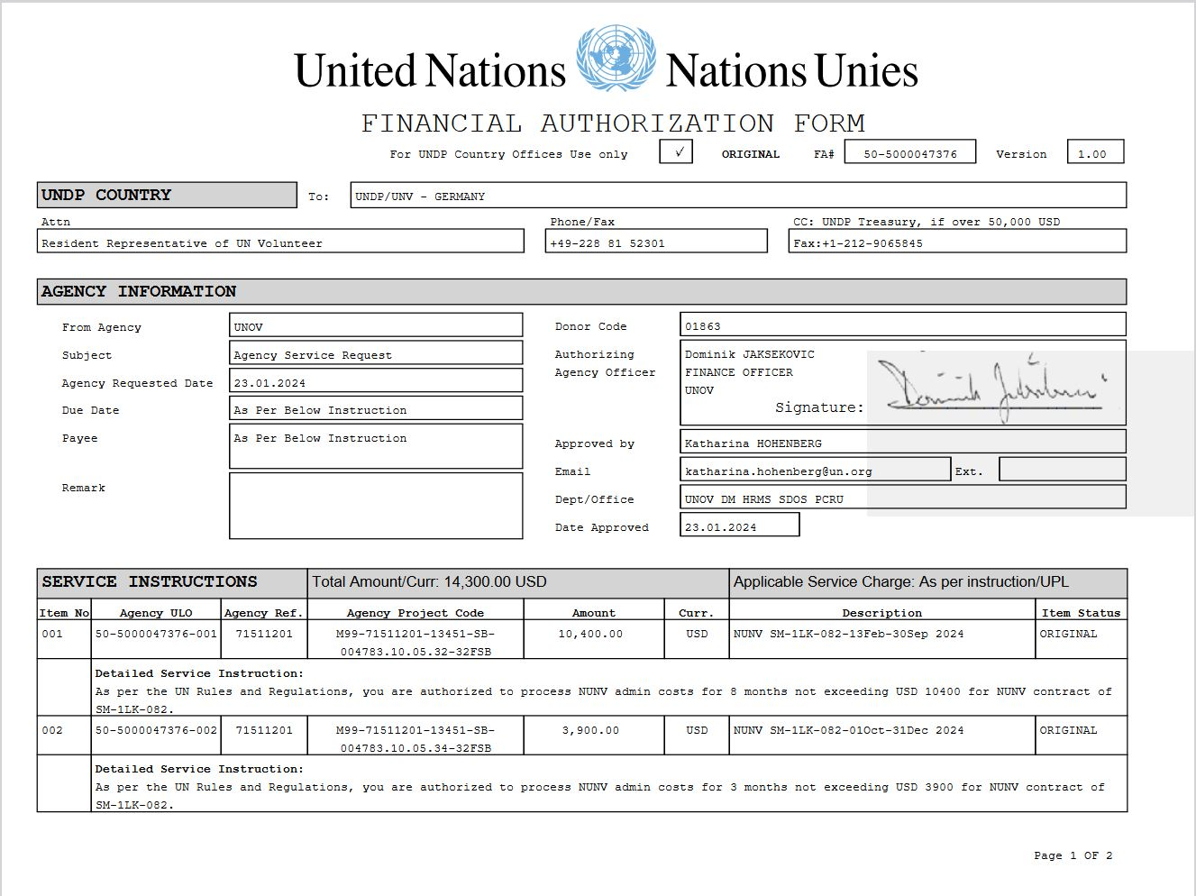

Annex 3: Sample of a non-UMOJA FA in a standard template shared by UNV

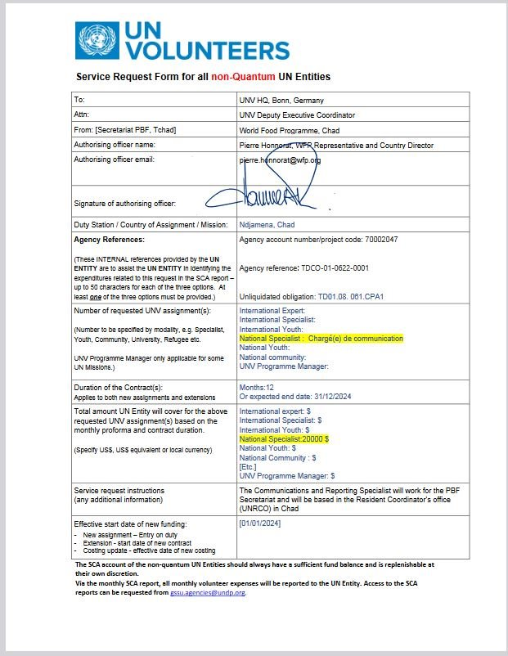

Quantum is the name of the corporate enterprise resource planning (ERP) system used by these entities.
This is the list of UN Entities using Quantum ERP as of December 2024. More entities may start using it in time.
PPM stands for Project and Portfolio Management and is a module in Quantum used for budget management and tracking. Some Quantum entities use it, while others don’t.
UMOJA is the name of the corporate enterprise resource planning (ERP) system used by these Entities.

